**Project Design Phase-II**

**Data Flow Diagram & User Stories**

|  |  |
| --- | --- |
| Date | 11 November Senthoor murugan A 2022 |
| Team ID | PNT2022TMID13382 |
| Project Name | Project – Car Resale Value Prediction |
| Maximum Marks | 4 Marks |

**Data Flow Diagrams:**

A Data Flow Diagram (DFD) is a traditional visual representation of the information flows within a system. A neat and clear DFD can depict the right amount of the system requirement graphically. It shows how data enters and leaves the system, what changes the information, and where data is stored.

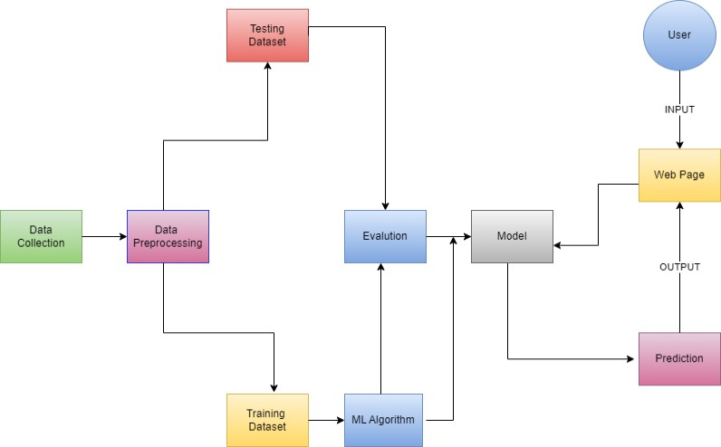

|  |  |  |
| --- | --- | --- |
|  | **DFD Level 0 (Car Resale Value prediction)** |  |
|  | | |

**User Stories:**

|  |  |  |  |  |  |  |
| --- | --- | --- | --- | --- | --- | --- |
| **User Type** | **Functional Requirement (Epic)** | **User Story Number** | **User Story / Task** | **Acceptance criteria** | **Priority** | **Release** |
| Customer (Mobile user) | Registration | USN-1 | As a user, I can register for the car details application by entering my email, password, and confirming my password. | I can access my dashboard and view the car details | High | Sprint-1 |
|  |  | USN-2 | As a user, I will receive car resale value in the application. | I can receive my car resale value in the application | High | Sprint-1 |
|  |  | USN-3 | As a user, I can register for the application through Facebook | I can register & access the dashboard with Facebook Login | Low | Sprint-2 |
|  |  | USN-4 | As a user, I can register for the application through Gmail | I can register & access the dashboard with Gmail Login | Medium | Sprint-1 |
|  | Login | USN-5 | As a user, I can log into the application by entering email & password | I can access my dashboard and view the car details | High | Sprint-1 |
|  | Dashboard | USN-1-5 | Show the details of different varieties of used cars. | I can know the resale value of a car | High | Sprint-1 |
|  | Dashboard | USN-1-5 | Show the time duration of the car was used in the past and predict the actual value | I know the current value of the car | High | Sprint-1 |